Aken 1

110 x 140

Välisuks 1

95 x 195

Aken 2

Hetkel tuulekojas sees- välisukse 1 kõrval

55 x 140

Aken 4

55 x 140

Aken 3

See aken tuleb põrandani (teraasiuks)

167 x 195

Välisuks 2

Hetkel väljast laudisega kinni löödud

90 x 195

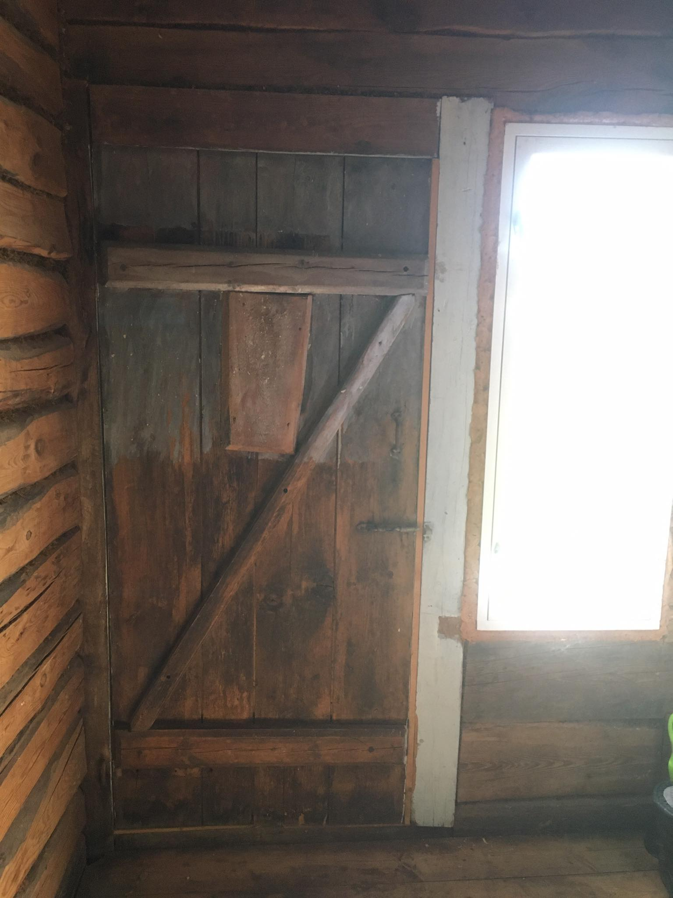

Välisuks 2 seest

Välisuks 3

Hetkel väljast laudisega kinni löödud

81 x 195

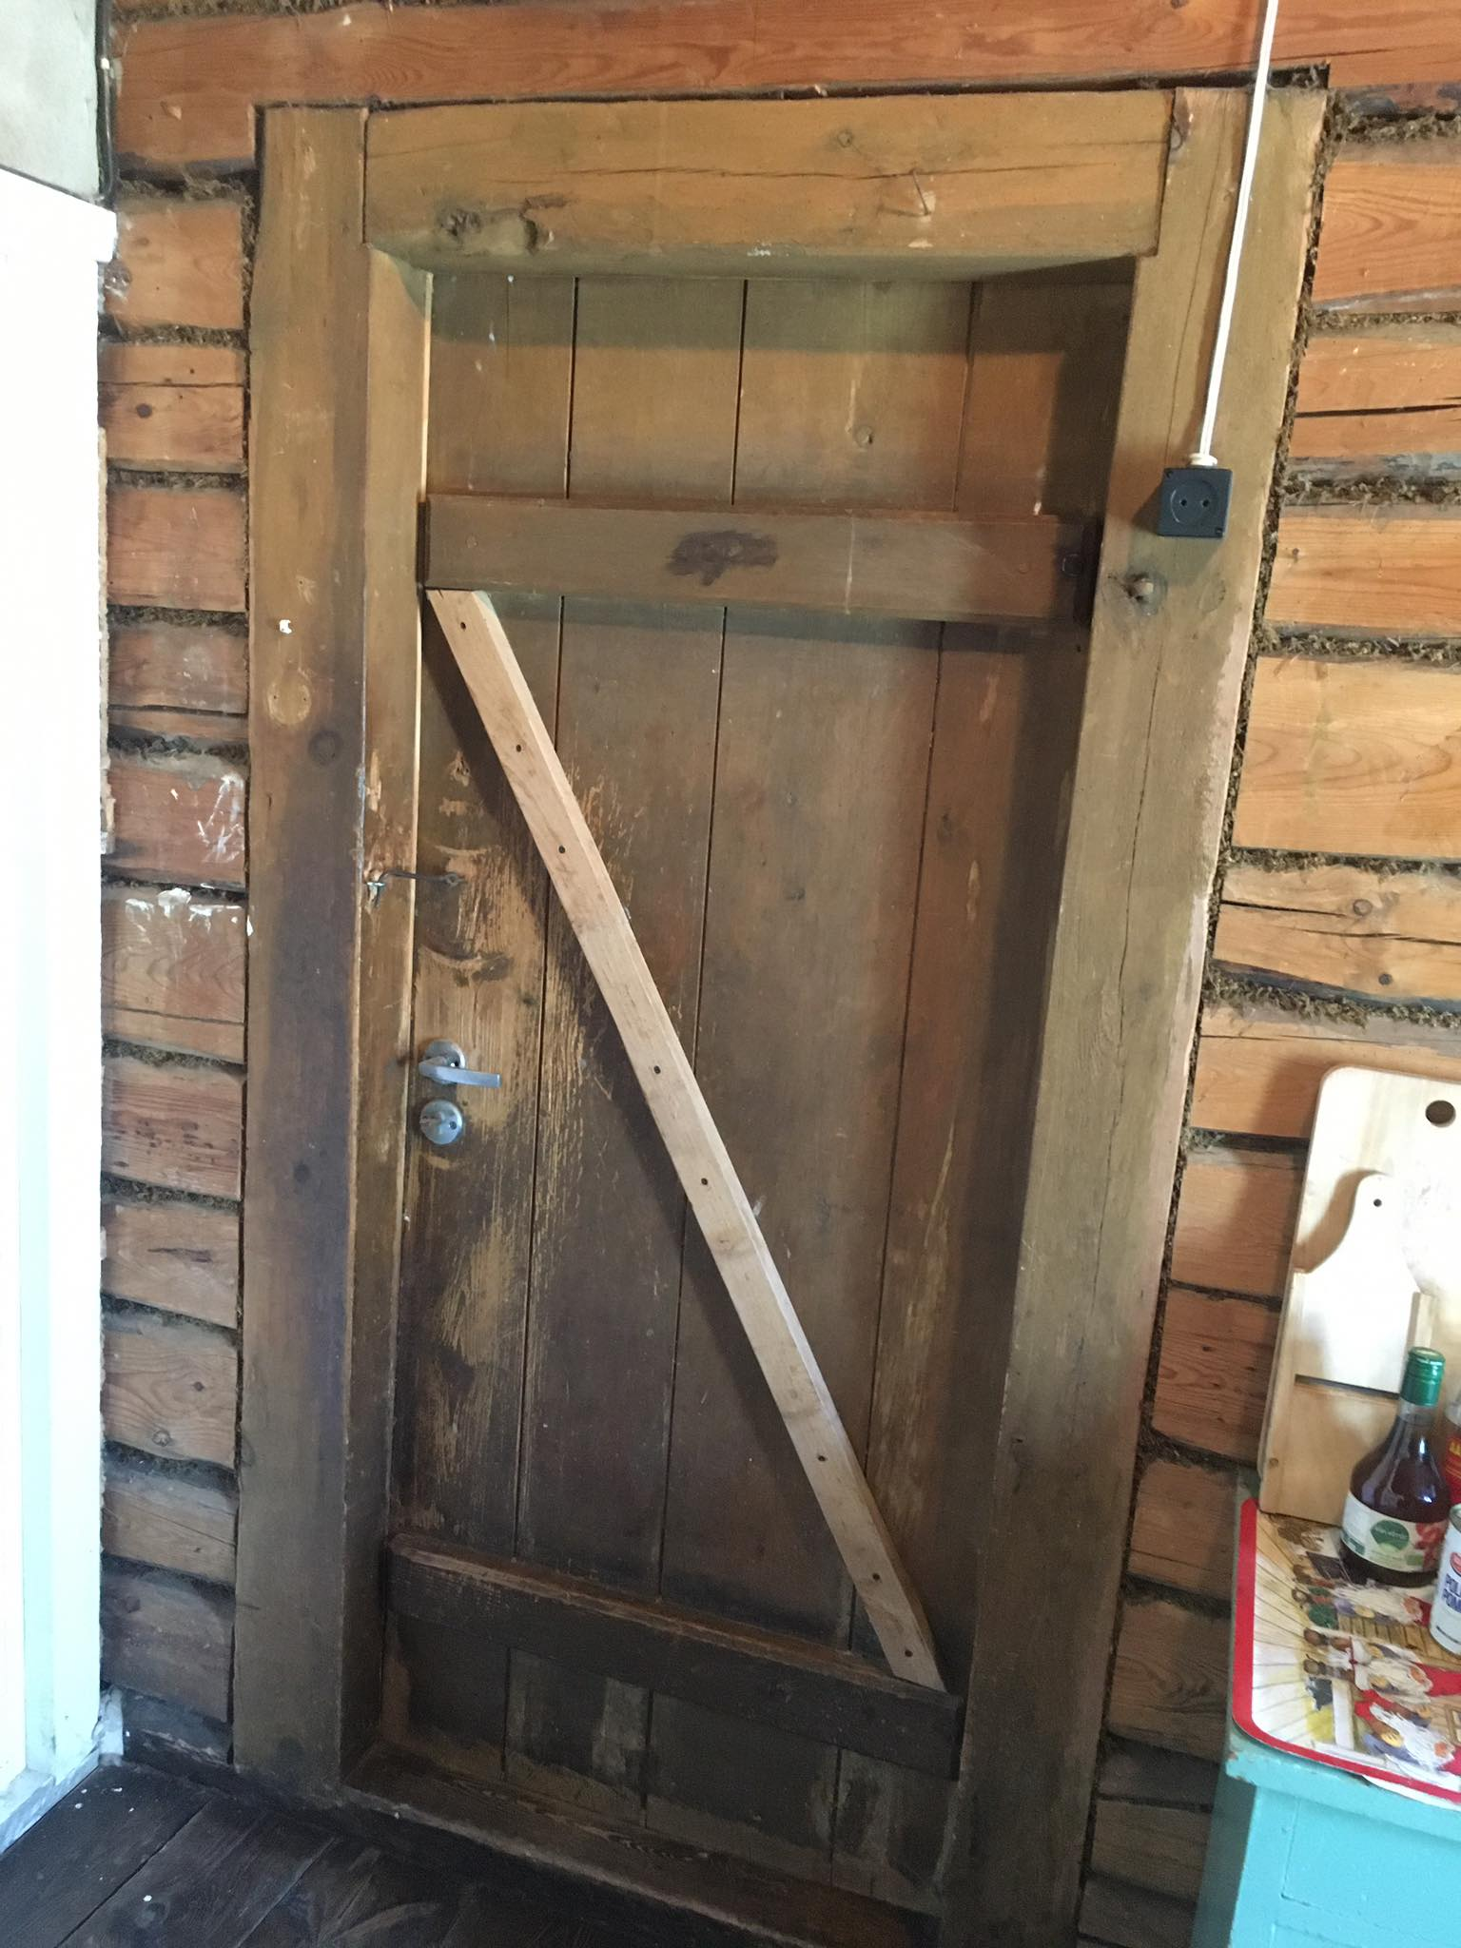

Välisuks 3 seest

Aken 7

110 x 140

Aken 6

110 x 140

Aken 5

55 x 140

Aken 7

110 x 140

Lakapealne

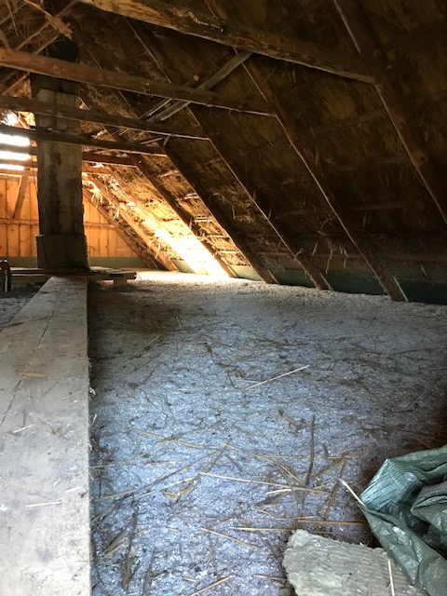

Lakapealne

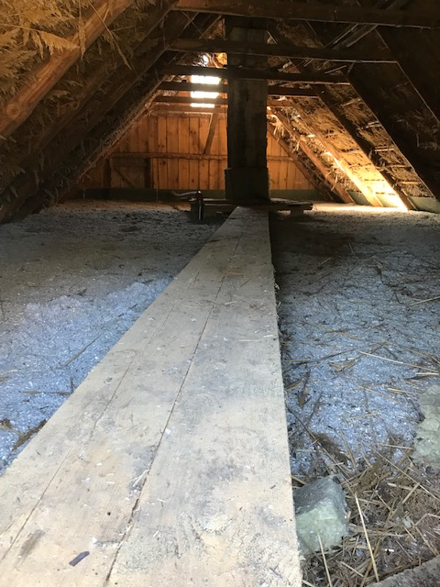

Lakapealne