Enamvähem sooviks sellist, võib teha ka omapoolseid soovitusi ja parandusi.

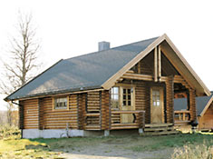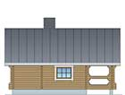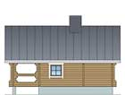

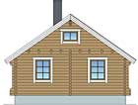 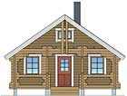

|  |  |  |  |  |  |  |  |  |  |  |  |  |  |  |  |
| --- | --- | --- | --- | --- | --- | --- | --- | --- | --- | --- | --- | --- | --- | --- | --- |
| |  | | --- | |  | |  | |  |  | | --- | --- | | |  | | --- | | http://www.honkamajat.fi/pohjapiirrokset/katri2-pohja_iso.jpg | | | |  | | --- | |  | | | |  | | --- | |  | | | |  | | --- | |  | | | |  | | --- | |  | | |  | |  |
|  |  | |  | | --- | |  | |  |
|  |  | |  | | --- | |  | |  |