1 |  |  |  | 2 |  | 3 | 4 |  | 5 |  | 6
 |  |  |  |  |  | 19454
 |  | 6223 |  |  |  | 5177 |  | 4500 |  | 3100
 | 2150 | 2400 | 2150 |  | 2200 | 1200 | 2200 | 3000 | 700 374 | 3080
 |  |  |  |  | 3850 |  | 475 | 3750 475 |  | 3750

Ruumide eksplikatsioon
Numb er | Nimetus | Pindala

33
1 | Magamistuba 1 | 15.30 m²
2 | Magamistuba 2 | 12.66 m²
3 | Magamistuba 3 | 11.91 m²
4 | Magamistuba 4 | 20.36 m²
5 | WC/Vannituba | 10.90 m²
6 | Koridor | 12.22 m²
7 | Elutuba | 51.39 m²
8 | Köök | 15.80 m²
9 | WC | 8.52 m²
10 | Koridor | 13.14 m²
11 | Esik | 9.77 m²
12 | Teh.ruum | 8.04 m²
13 | Garaaz | 40.39 m²

D
1685
Magamistuba 4
3100
3100

⁴ 34
4633
112 3420
4400
419
714 1016
20 m² 30

E

21 32
WC/Vannituba

4377
1200
2491

27
5760
112

5

11 m²
112 1463 274463 864

22
3848
4226

30
5487
475
3000
5760

1
AR-6-01

C
21074
475
21074

Magamistuba 3

27 3
1200
1575
2722
- m²
1825
112

Magamistuba 2

2
1200
2892

27
- m²
2026
Koridor 6
12 m²

23

24

29

25
5940

27
1949 397

26

Koridor
4553

Elutuba 7
51 m²

2861
WC 9
3026
9 m²

35
4400
Köök 27
3739
8
16 m²
274
Kokku

C
230.41 m²

Magamistuba 1
1200 1762
2676 112
1200 840
5940
1
10

28
13 m²

274

Teh.ruum

27 5952

B
1613

33
965
2437

15 m²

274 2768 112

33
2020 30
Esik 11

31
10 m²
12

8 m²
4226 28

B
274
1903
1260 352 1200

28
1200
Garaaz 13
5529
1763
5800

40 m²
5800
730 1125
475

475 4276 475 4278
1200

A
847

28 28

32 A
854
1200
11/28/2021 9:44:21 PM

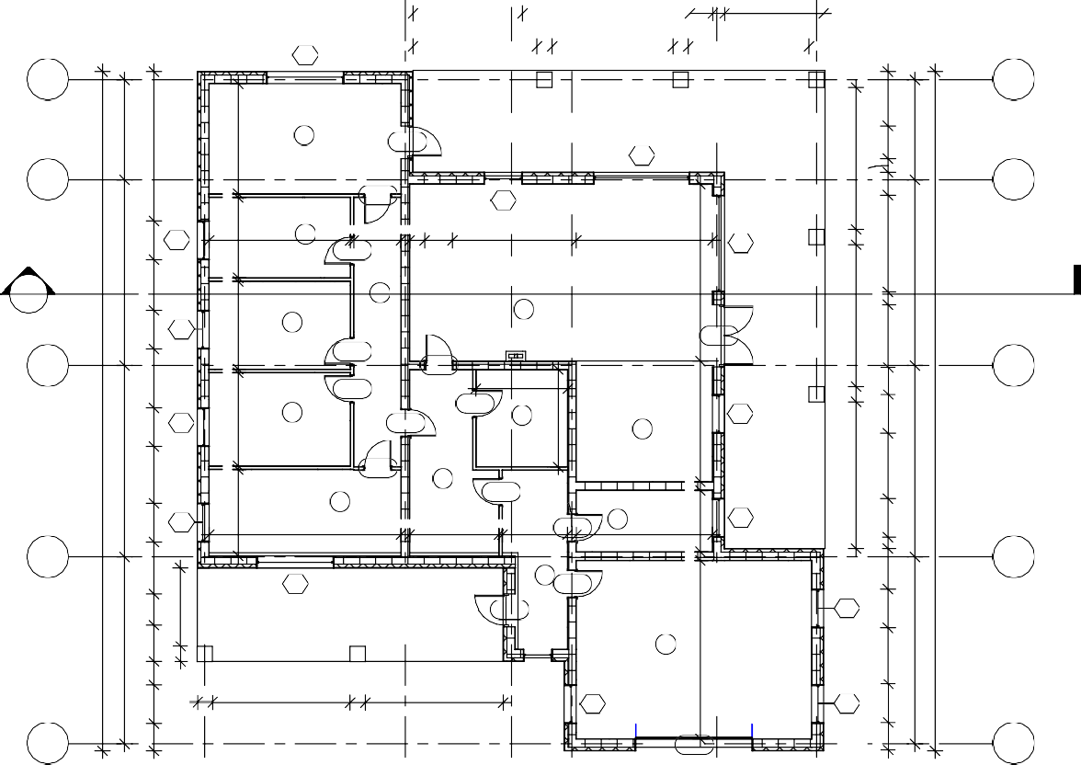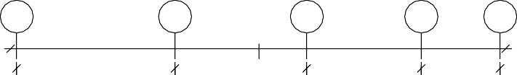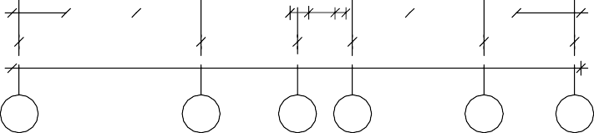
 | 1845 | 2400 | 5259 |  | 621 900 376 |  | 2200 |  | 3651 |  |  | 2203
 |  | 6223 |  | 3297 | 1880 |  |  | 4500 |  |  | 3100
 |  |  |  |  | 19454
1 |  |  | 2 |  | 3 | 4 |  |  |  | 5 |  |  | 6

